Day 1 | - 10.00-11.30am: Lecture 1 - Brief intro to FPD  - 11.30-12.00pm: Tea break  - 12.00-1.30pm: Lecture 2 - Relevance of FPD along with treatment planning  - 1.30-2.30pm: Lunch Break  - 2.30-4.30pm: Discussion
Day 2 | - 10.00-11.30pm: Lecture 3 - Principles of Tooth preparation  - 11.30-12.00pm: Tea break  - 12.00-1.30pm: Lecture 4 - Principles of Tooth preparation contd.  - 1.30-2.30pm: Lunch break  - 2.30-4.30pm: Discussion
Day 3 | - 10.00-11.30am: Lecture 5- Tooth preparation for ALL CERAMICS & PFM  - 11.30am -12.00pm: Tea break  - 12.00-1.30pm: Lecture 6- Choice of materials for FPD  - 1.30-2.30pm: Lunch break  - 2.30-4.30pm: Discussion
Day 4 | Recreation – Trek to Murari Temple / Lake Parashar/ Lake Riwalsar/ Camping at Tirthan Valley/ Kasol / Koldam
Day 5 | LIVE DEMO of tooth preparation
Day 6 | HANDS ON
Day 7 | Recreation – Excursion to the Holy city of Mandi / Lake Prashar/ Lake Riwalsar / Camping at Tirthan Valley / Kasol/ Koldam
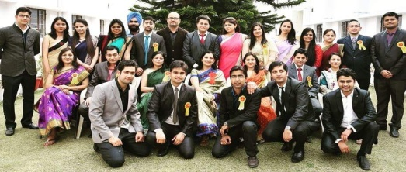
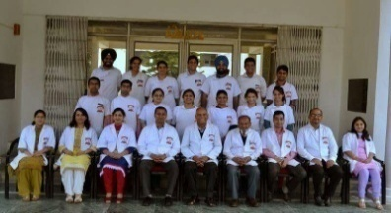
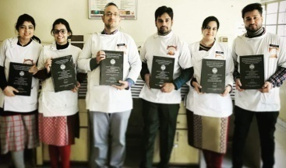
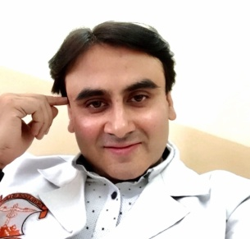
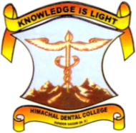
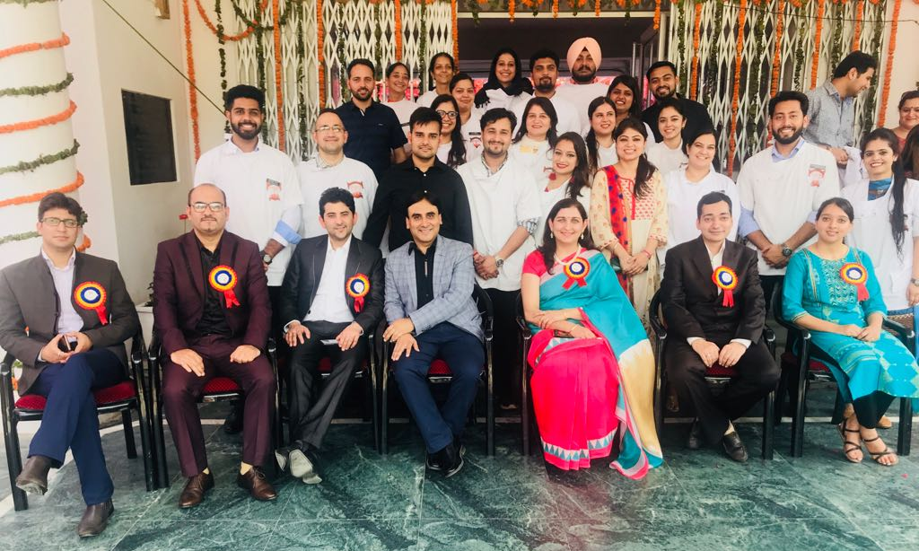
Dr. Rajeev Gupta
Professor

THEME : LEARNING ABOUT FPD
Dr. Archana Nagpal
Professor & H.O.D

DEPARTMENT OF PROSTHODONTICS AND CROWN & BRIDGE
INTERNATIONAL STUDENT EXCHANGE PROGRAM – 2018
MODULE 2 (7 DAYS)

