Day 1 | - 9.30 -10.00 am: Inauguration and Welcome  - 10.00- 11.30 am : Lecture 1 – Introduction to Complete Dentures  - 11.30 am -12.00 pm : Tea Break  - 12.00- 1.30 pm : Lecture 2 – Mouth Preparation for CD  - 1.30- 2.30 pm: Lunch Break  - 2.30- 4.30 pm: Lecture 3 – Primary Impressions in Complete Denture
Day 2 | - 10.00- 11.30 am: Lecture 4 - Secondary Impression in Complete Denture  - 11.30 am - 12.00 pm: Tea Break  - 12.00 - 1.30 pm: Lecture 5 - Maxillomandibular Relations  - 1.30-2.30 pm: Lunch Break  - 2.30- 4.30 pm: Lecture 6 – Introduction to Semi adjustable Articulators and Balanced Occlusion
Day 3 | - 10.00-11.30 am: Lecture 7 – Facebow & Teeth Arrangement  - 11.30 am – 12.00 pm : Tea Break  - 12.00 – 1.30 pm :Lecture 8 : Teeth selection, Try in and Denture Insertion  - 1.30– 2.30 pm : Lunch  - 2.30 – 4.00 pm : Group Discussion
Day 4 | Recreation – Trek to Murari Temple / Lake Parashar/ Lake Riwalsar/ Camping at Tirthan Valley/ Kasol / Koldam
Day 5 | HANDS ON
Day 6 | HANDS ON
Day 7 | Recreation – Excursion to the Holy city of Mandi / Lake Prashar/ Lake Riwalsar / Camping at Tirthan Valley / Kasol/ Koldam  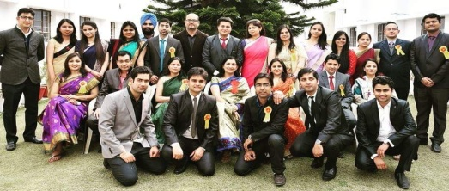
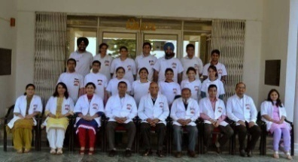
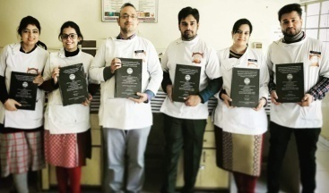
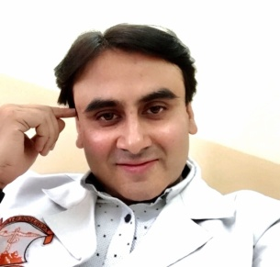
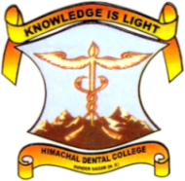
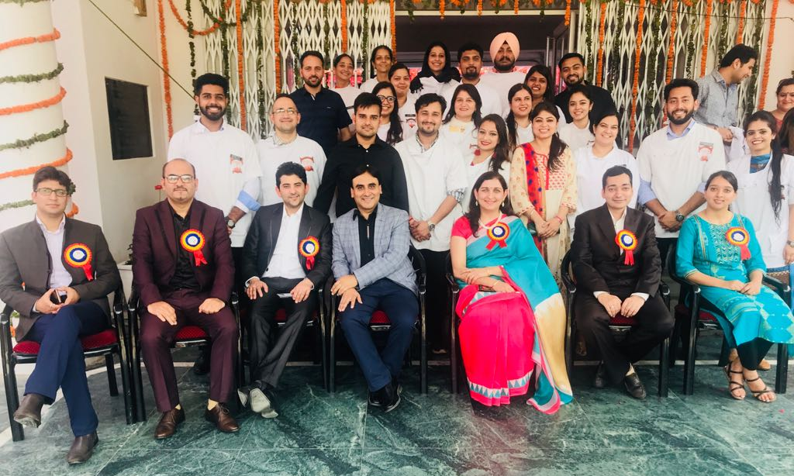
Dr. Rajeev Gupta
Professor

THEME : TOWARDS MAKING A COMPLETE DENTURE
Dr. Archana Nagpal
Professor & H.O.D

DEPARTMENT OF PROSTHODONTICS AND CROWN & BRIDGE
INTERNATIONAL STUDENT EXCHANGE PROGRAM – 2018
MODULE 1 (7 DAYS)

